***Introducing End-To-End IP Communications***

***TCP/IP Protocol Stack Review***

|  |  |  |  |
| --- | --- | --- | --- |
| OSI | TCP/IP | Actual |  |
| Application | Application | Application | Application data/payload |
| Presentation |
| Session |
| Transport | Transport | Transport | Segments |
| Network | Internet | Network | Packets |
| Datalink | Network Access | Datalink | frames |
| Physical | Physical | bits |

Application – HTTP, web browser

Transport – TCP, port

Network – Ip address source and destination.

Data Link – L2 Mac address, source, and destination.

Physical – individual bits or signals 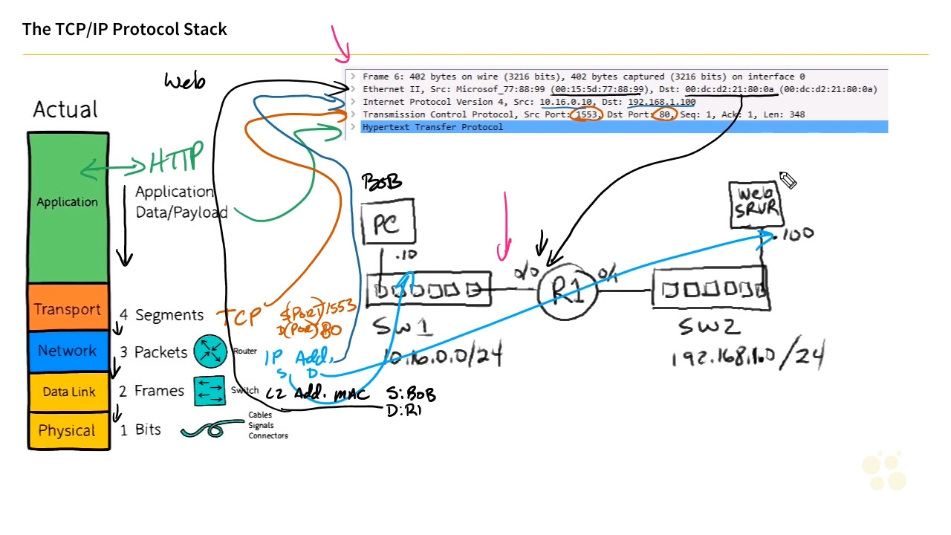

***Routers and Multilayer Switches***

Which of the following is the name of the logical Layer 3 interface that a multilayer switch uses to provide a routed interface for a local VLAN? (Choose two)

Interface VLAN X (where x is the vlan number)

Switched Virtual Interface (SVI)

***Predicting the correct L2 and L3 Addresses***

The information exchanged at a layer 2 protocol is the source and destination MAC address. Remember this is a layer 2 device exchanging this information. So when you want to send information your source and destination are based on you and your neighboring devices MAC addresses.

If Network Address Translation (NAT) isn't being used at layer 3, the source and destination layer address are never changed as the packet is forwarded by routers over the network. True or false?

True

If a computer on VLAN 5 is sending a packet to a device on VLAN 6, which layer 2 destination address should the computer use?

The default gateway layer 2 destination address

***Logical and Physical Topologies Lab***

Which L3 interface on a multilayer switch will be used in VLAN 40?

Interface vlan 40

***Identifying and Correcting a Layer 2 Path***

First thing you want to do even though you know from memory is to draw out the connections between devices. Although it might not help you now, when you have troubleshooting issues, it is good to have some sort of reference.

We can start looking at the spanning-tree typology by doing.

#show spanning-tree vlan 10

Using this command, we can see which way the traffic is flowing between the devices on the network. Doing this on every switch we can start creating a map showing the network traffic. This way we can identify the path the traffic is taking. If it is not the optimal path, we can change this by changing the root device.

>#spanning-tree vlan 10 priority 4096

># spanning-tree root priority

To detect and prevent loops in a layer 2 Ethernet network, which mechanism is used?

STP

***Topology and Lab Strategy***